Project Planning - [Milestone, Activity List & Sprint Delivery Plan]

|  |  |
| --- | --- |
| Date | 19 November2022 |
| Team ID | PNT2022TMID50196 |
| Project Name | Exploratory Analysis of RainFall Data in India for Agriculture |
| Maximum Marks | 8 Marks |

Product Backlog, Sprint Schedule, and Estimation:

|  |  |  |  |  |  |  |
| --- | --- | --- | --- | --- | --- | --- |
| **Sprint** | **Functional Requirement**  **[Epic]** | **User Story Number** | **User Story / Task / Activity** | **Story Points** | **Priority** | **Team Members** |
| Sprint-1 | Registration | USN-1 | User can register for the application by entering his or her email, password, and confirming the password | 5 | High | Vivekanandhan, Soumen |
| Sprint-1 |  | USN-2 | User will receive confirmation email or message once registered for the application | 3 | High | Rakesh, Sudharsan |
| Sprint-1 |  | USN-3 | Validation of the user can be done directly using email or OTP | 2 | Medium | Rakesh, Soumen |
| Sprint-1 | Login | USN-4 | Enter the username and password to login to the application | 2 | High | Rakesh, Sudharsan, Soumen |
| Sprint-1 |  | USN-5 | The existing credentials should be used for login on multiple systems | 1 | Medium | Sudharsan, Vivekanandhan |
| Sprint-1 | Dashboard | USN-6 | User can search for the region where he/she wants to know the prediction of rainfall | 5 | High | Vivekanandhan, Rakesh, Soumen |

|  |  |  |  |  |  |  |
| --- | --- | --- | --- | --- | --- | --- |
| **Sprint** | **Functional Requirement**  **[Epic]** | **User Story Number** | **User Story / Task / Activity** | **Story Points** | **Priority** | **Team Members** |
| Sprint-2 |  | USN-7 | User can view the visualization of the rainfall data for a specific region in India or for a specific time period | 3 | Medium | Vivekanandhan, Soumen |
| Sprint-2 |  | USN-8 | User can change his/her password and can view the account details and search  history | 5 | High | Vivekanandhan, Soumen, Rakesh |
| Sprint-2 |  | USN-9 | The prediction or analysis request can be asked for the desired region for future or past events respectively | 8 | High | Sudharsan, Rakesh, Soumen |
| Sprint-3 |  | USN-10 | User can give the feedback on the accuracy of the prediction and on the user interface | 5 | High | Vivekanandhan, Rakesh |
| Sprint-3 | Support | USN-11 | Responds to user queries via telephone, email etc. | 2 | Medium | Sudharsan, Rakesh |
| Sprint-3 |  | USN-12 | The team must analyze all the queries and try to debug and make plans so that  such queries wouldn’t be raised again | 1 | Low | Sudharsan, Soumen |
| Sprint-3 |  | USN-13 | Organize for a FAQ session where  commonly asked doubts can be redressed by the team | 1 | Low | Rakesh, Vivekanandhan |
| Sprint-3 |  | USN-14 | The team must respond immediately to  the queries based on the priority | 5 | High | Rakesh, Sudharsan |
| Sprint-4 | Core Function | USN-13 | Design, develop the application in such  a way that the best user interface and maintenance should be taken care of | 8 | High | Vivekanandhan, Soumen |
| Sprint-4 |  | USN-14 | The website is responsive on all the  devices and the screen sizes | 2 | Medium | Vivekanandhan, Rakesh, Sudharsan |
| Sprint-4 |  | USN-15 | The updates should be on time with the  solutions of the raised queries | 5 | High | Rakesh, Sudharsan |

Project Tracker, Velocity & Burndown Chart:

|  |  |  |  |  |  |  |
| --- | --- | --- | --- | --- | --- | --- |
| **Sprint** | **Total Story Points** | **Duration** | **Sprint Start Date** | **Sprint End Date (Planned)** | **Story Points Completed (as on**  **Planned End Date)** | **Sprint Release Date (Actual)** |
| Sprint-1 | 18 | 6 Days | 24 Oct 2022 | 29 Oct 2022 | --- | 29 Oct 2022 |
| Sprint-2 | 16 | 6 Days | 31 Oct 2022 | 05 Nov 2022 | --- | 05 Nov 2022 |
| Sprint-3 | 14 | 6 Days | 07 Nov 2022 | 12 Nov 2022 | --- | 12 Nov 2022 |
| Sprint-4 | 15 | 6 Days | 14 Nov 2022 | 19 Nov 2022 | --- | 19 Nov 2022 |

# Velocity:

Average Sprint Velocity *[estimated to be ideal]* = St#$y p#()t* t# +e c#mp/ete0 #1t #2 3// 1*e$ *t#$(e* = 56 = 15.75

4#t3/ )1m+e$ #2 Sp$()t* 7

Therefore, the amount of work to be done on each sprint is an average of 15.75 story points.

# Burndown Chart:

Project progress made till now over time is not measurable under the burnout chart. The chart would be updated later based on the completion of each sprint.

Roadmap & Timeline: Total Tools Used: 02

*Tool used:* ***JIRA Software***

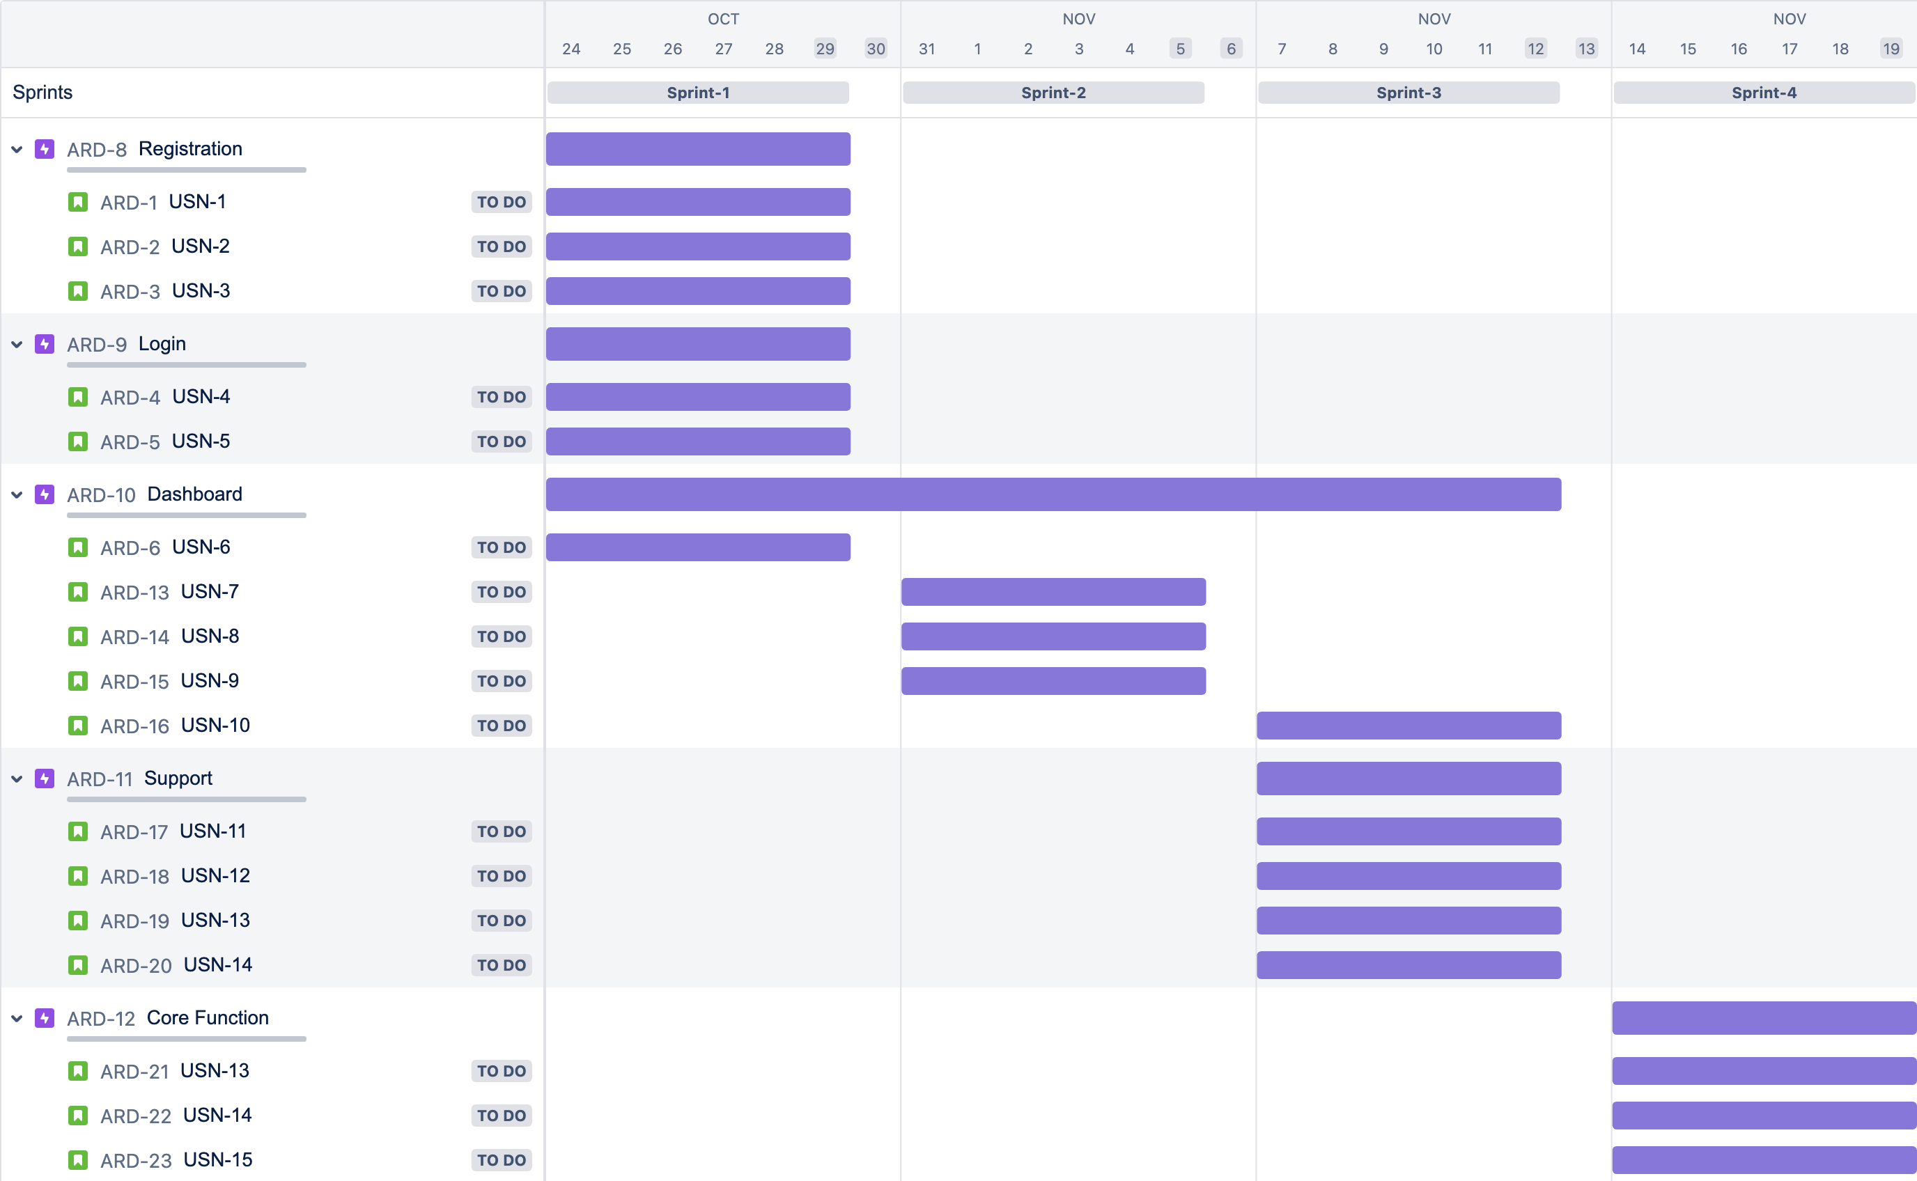

*Tool Used:* ***Asana***

